Oblique Parallelepiped

Definition
# Source: AI Source: Provided by: [Data Path: Persons Table -> ID Column: 1, Name_En Column: Motasem Essam] -> From: [ChatGPT] on [7/25/2026]
An oblique parallelepiped is a three-dimensional polyhedron with six parallelogram-shaped faces in which the lateral edges are inclined to the base plane rather than perpendicular to it.
Its opposite faces are parallel and congruent, but its adjacent faces do not necessarily meet at right angles.
The perpendicular distance between its two parallel bases is called its height, which is generally shorter than the length of its inclined lateral edges.

Simple Definition
# Source: AI Source: Provided by: [Data Path: Persons Table -> ID Column: 1, Name_En Column: Motasem Essam] -> From: [ChatGPT] on [7/25/2026]
An oblique parallelepiped is a slanted box-shaped solid with six parallelogram faces, where its lateral edges are inclined instead of perpendicular to its base.
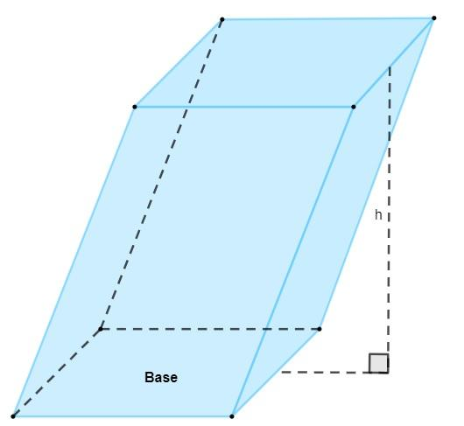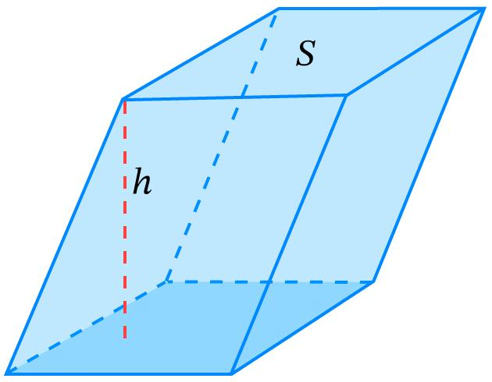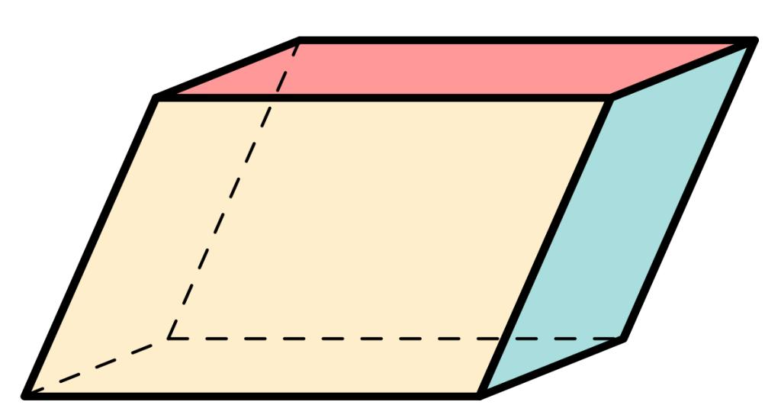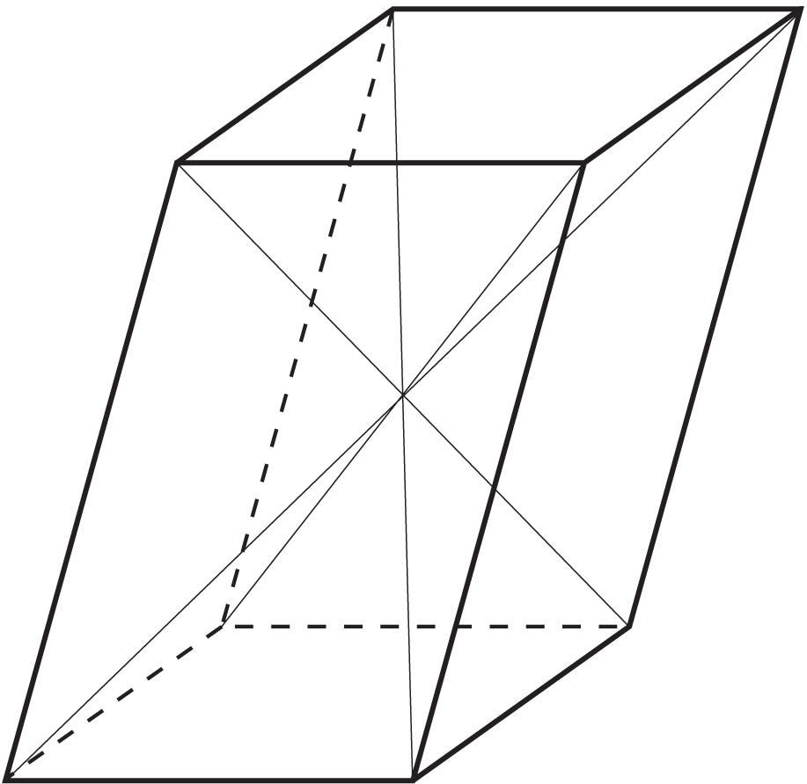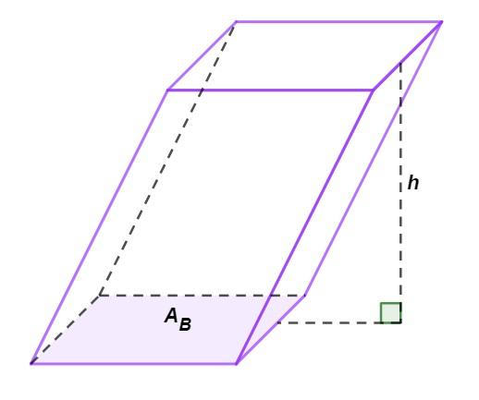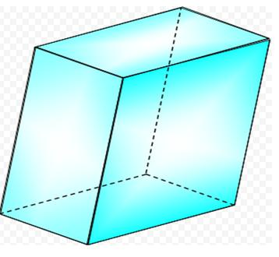

Geometric Structure
# Source: AI Source: Provided by: [Data Path: Persons Table -> ID Column: 1, Name_En Column: Motasem Essam] -> From: [ChatGPT] on [7/25/2026]
An oblique parallelepiped has the same basic number of geometric elements as any parallelepiped.
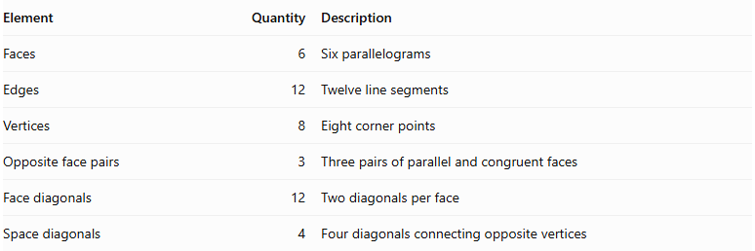
Element | Quantity | Description
Faces | 6 | Six parallelograms
Edges | 12 | Twelve line segments
Vertices | 8 | Eight corner points
Opposite face pairs | 3 | Three pairs of parallel and congruent faces
Face diagonals | 12 | Two diagonals per face
Space diagonals | 4 | Four diagonals connecting opposite vertices

Bases
# Source: AI Source: Provided by: [Data Path: Persons Table -> ID Column: 1, Name_En Column: Motasem Essam] -> From: [ChatGPT] on [7/25/2026]
The two bases are opposite, parallel, and congruent parallelograms.
The base area is:
$$A_{b}=absinθ$$
Where:
- $a$ and $b$ are adjacent base-edge lengths.
- $θ$ is the included angle between them.

Lateral Faces
# Source: AI Source: Provided by: [Data Path: Persons Table -> ID Column: 1, Name_En Column: Motasem Essam] -> From: [ChatGPT] on [7/25/2026]
The four lateral faces are parallelograms.
Unlike a right parallelepiped, these faces are generally not rectangles because the lateral edges are inclined to the base plane.

Lateral Edges
# Source: AI Source: Provided by: [Data Path: Persons Table -> ID Column: 1, Name_En Column: Motasem Essam] -> From: [ChatGPT] on [7/25/2026]
The lateral edges connect corresponding vertices of the two bases.
They are:
- Parallel to one another.
- Equal in length.
- Inclined relative to the base plane.

Height
# Source: AI Source: Provided by: [Data Path: Persons Table -> ID Column: 1, Name_En Column: Motasem Essam] -> From: [ChatGPT] on [7/25/2026]
The height is the perpendicular distance between the two parallel base planes.
It is not the same as the length of an inclined lateral edge.

Main Classification of Oblique Parallelepipeds
# Source: AI Source: Provided by: [Data Path: Persons Table -> ID Column: 1, Name_En Column: Motasem Essam] -> From: [ChatGPT] on [7/25/2026]
Oblique parallelepipeds can be classified according to the shape of their bases and the relationships between their edge directions.

Rectangular-Base Oblique Parallelepiped
# Source: AI Source: Provided by: [Data Path: Persons Table -> ID Column: 1, Name_En Column: Motasem Essam] -> From: [ChatGPT] on [7/25/2026]
This is an oblique parallelepiped whose two bases are rectangles, while its lateral edges are inclined to the base plane.
Its lateral faces are generally parallelograms rather than rectangles.
Characteristics:
- Two rectangular bases.
- Four generally parallelogram-shaped lateral faces.
- Inclined lateral edges.
- Opposite faces are parallel and congruent.

Square-Base Oblique Parallelepiped
# Source: AI Source: Provided by: [Data Path: Persons Table -> ID Column: 1, Name_En Column: Motasem Essam] -> From: [ChatGPT] on [7/25/2026]
This is an oblique parallelepiped whose two bases are squares.
The lateral edges are inclined to the square base plane.
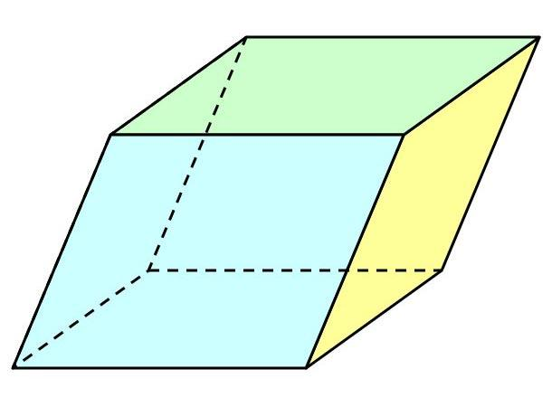
Characteristics:
- Two congruent square bases.
- Four parallelogram lateral faces.
- Equal base edges.
- Inclined lateral edges.

Rhombus-Base Oblique Parallelepiped
# Source: AI Source: Provided by: [Data Path: Persons Table -> ID Column: 1, Name_En Column: Motasem Essam] -> From: [ChatGPT] on [7/25/2026]
This is an oblique parallelepiped whose two bases are rhombuses.
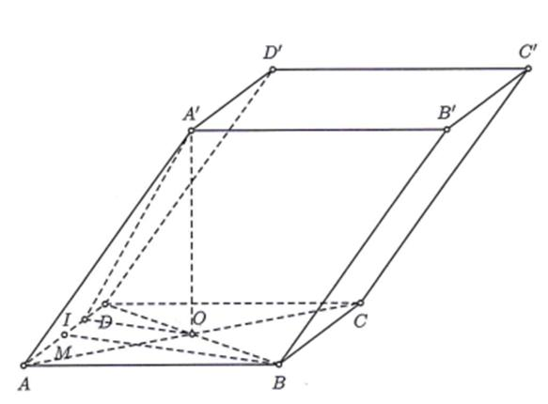
Characteristics:
- Two congruent rhombus bases.
- Four parallelogram lateral faces.
- All four base edges have equal lengths.
- Lateral edges are inclined to the base plane.

General Parallelogram-Base Oblique Parallelepiped
# Source: AI Source: Provided by: [Data Path: Persons Table -> ID Column: 1, Name_En Column: Motasem Essam] -> From: [ChatGPT] on [7/25/2026]
This is an oblique parallelepiped whose bases are general parallelograms, with adjacent sides that may have different lengths and angles that are not right angles.
Characteristics:
- Two congruent parallelogram bases.
- Base angles are not necessarily right angles.
- Adjacent base edges may have different lengths.
- Lateral edges are inclined to the base plane.
Note: These four types classify the base shape. They are not four fundamentally different solid families; they are variations of the same oblique parallelepiped structure.

Classification by Inclination
# Source: AI Source: Provided by: [Data Path: Persons Table -> ID Column: 1, Name_En Column: Motasem Essam] -> From: [ChatGPT] on [7/25/2026]
The inclination of the lateral edges can also be used to describe an oblique parallelepiped.

Slightly Inclined Parallelepiped
# Source: AI Source: Provided by: [Data Path: Persons Table -> ID Column: 1, Name_En Column: Motasem Essam] -> From: [ChatGPT] on [7/25/2026]
The lateral edges make a relatively large angle with the base plane, close to ${90}^{∘}$, but are not perpendicular to it.
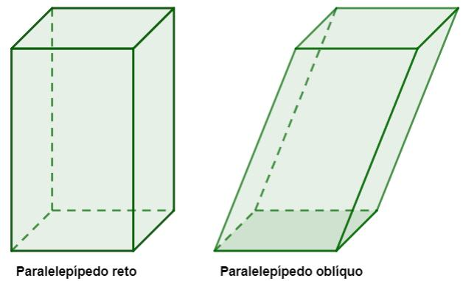

Strongly Inclined Parallelepiped
# Source: AI Source: Provided by: [Data Path: Persons Table -> ID Column: 1, Name_En Column: Motasem Essam] -> From: [ChatGPT] on [7/25/2026]
The lateral edges make a smaller angle with the base plane, producing a more visibly slanted solid.

Inclination Angle
# Source: AI Source: Provided by: [Data Path: Persons Table -> ID Column: 1, Name_En Column: Motasem Essam] -> From: [ChatGPT] on [7/25/2026]
The angle of inclination $α$ is measured between a lateral edge and the base plane.
For an oblique parallelepiped:
$$0^{∘}<α<{90}^{∘}$$
If the lateral edge has length $s$, the perpendicular height is:
$$\boxed{h=ssinα}$$
The horizontal displacement of the lateral edge is:
$$\boxed{x=scosα}$$
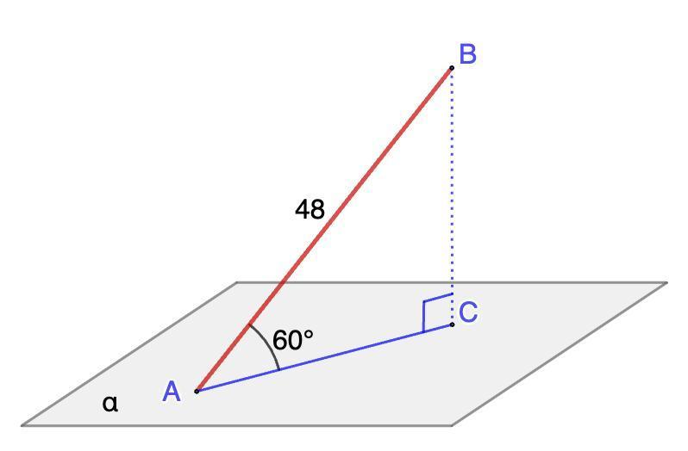

Mathematical Properties and Formulas
# Source: AI Source: Provided by: [Data Path: Persons Table -> ID Column: 1, Name_En Column: Motasem Essam] -> From: [ChatGPT] on [7/25/2026]
Let:
- $a$ = first base-edge length.
- $b$ = second base-edge length.
- $c$ = lateral-edge length.
- $θ$ = included angle between the base edges.
- $α$ = angle of inclination of the lateral edges to the base plane.
- $h$ = perpendicular height.

Base Area
# Source: AI Source: Provided by: [Data Path: Persons Table -> ID Column: 1, Name_En Column: Motasem Essam] -> From: [ChatGPT] on [7/25/2026]
The base is a parallelogram.
$$\boxed{A_{b}=absinθ}$$

Height
# Source: AI Source: Provided by: [Data Path: Persons Table -> ID Column: 1, Name_En Column: Motasem Essam] -> From: [ChatGPT] on [7/25/2026]
If the lateral-edge length is $c$:
$$\boxed{h=csinα}$$

Volume
# Source: AI Source: Provided by: [Data Path: Persons Table -> ID Column: 1, Name_En Column: Motasem Essam] -> From: [ChatGPT] on [7/25/2026]
The volume equals the base area multiplied by the perpendicular height.
$$V=A_{bh}$$
Therefore:
$$\boxed{V=abhsinθ}$$
Or, using the lateral-edge length and inclination:
$$\boxed{V=abcsinθsinα}$$

Surface Area
# Source: AI Source: Provided by: [Data Path: Persons Table -> ID Column: 1, Name_En Column: Motasem Essam] -> From: [ChatGPT] on [7/25/2026]
The total surface area is the sum of the areas of all six parallelogram faces.
Let:
- $α$ be the angle between base edge $a$ and lateral edge $c$.
- $β$ be the angle between base edge $b$ and lateral edge $c$.
Then:
$$\boxed{SA=2absinθ+2acsinα+2bcsinβ}$$
This formula assumes the stated angles are the included angles between the corresponding edge directions.

Lateral Surface Area
# Source: AI Source: Provided by: [Data Path: Persons Table -> ID Column: 1, Name_En Column: Motasem Essam] -> From: [ChatGPT] on [7/25/2026]
The lateral surface area is the sum of the four lateral parallelograms:
$$\boxed{LSA=2acsinα+2bcsinβ}$$

Space Diagonals
# Source: AI Source: Provided by: [Data Path: Persons Table -> ID Column: 1, Name_En Column: Motasem Essam] -> From: [ChatGPT] on [7/25/2026]
An oblique parallelepiped has four space diagonals.
Unlike a rectangular parallelepiped, these diagonals are not necessarily equal in length.
For a parallelepiped with edge vectors $veca,vecb,vecc$, the four diagonal vectors can be represented by:
$$veca+vecb+vecc$$
$$veca+vecb-vecc$$
$$veca-vecb+vecc$$
$$-veca+vecb+vecc$$
Their lengths depend on the magnitudes and directions of the three edge vectors.

Worked Examples

Example 1: Calculating the Volume of an Oblique Parallelepiped
# Source: AI Source: Provided by: [Data Path: Persons Table -> ID Column: 1, Name_En Column: Motasem Essam] -> From: [ChatGPT] on [7/25/2026]
An oblique parallelepiped has:
- Base edge $a=8$ cm.
- Base edge $b=5$ cm.
- Base included angle $θ={60}^{∘}$.
- Lateral edge $c=10$ cm.
- Lateral-edge inclination $α={30}^{∘}$.
Find its perpendicular height and volume.
Step 1: Calculate the perpendicular height.
$$h=csinα$$
$$h=10sin{30}^{∘}$$
$$h=10×0.5$$
$$\boxed{h=5 cm}$$
Step 2: Calculate the base area.
$$A_{b}=absinθ$$
$$A_{b}=8×5×sin{60}^{∘}$$
$$A_{b}=40×\frac{\sqrt{3}}{2}$$
$$\boxed{A_{b}=20\sqrt{3}{ cm}^{2}}$$
Step 3: Calculate the volume.
$$V=A_{bh}$$
$$V=20\sqrt{3}×5$$
$$\boxed{V=100\sqrt{3}{ cm}^{3}}$$
$$\boxed{V≈173.21{ cm}^{3}}$$

Example 2: Calculating the Surface Area
# Source: AI Source: Provided by: [Data Path: Persons Table -> ID Column: 1, Name_En Column: Motasem Essam] -> From: [ChatGPT] on [7/25/2026]
An oblique parallelepiped has:
- $a=6$ cm.
- $b=4$ cm.
- $c=5$ cm.
- Angle between $a$ and $b$: $θ={60}^{∘}$.
- Angle between $a$ and $c$: $α={60}^{∘}$.
- Angle between $b$ and $c$: $β={90}^{∘}$.
Find its total surface area.
Step 1: Calculate the base-face area.
$$A_{1}=absinθ$$
$$A_{1}=6×4×sin{60}^{∘}$$
$$A_{1}=12\sqrt{3}$$
Step 2: Calculate the second face area.
$$A_{2}=acsinα$$
$$A_{2}=6×5×sin{60}^{∘}$$
$$A_{2}=15\sqrt{3}$$
Step 3: Calculate the third face area.
$$A_{3}=bcsinβ$$
$$A_{3}=4×5×sin{90}^{∘}$$
$$A_{3}=20$$
Step 4: Calculate the total surface area.
$$SA=2(A_{1}+A_{2}+A_{3})$$
$$SA=2(12\sqrt{3}+15\sqrt{3}+20)$$
$$\boxed{SA=54\sqrt{3}+40{ cm}^{2}}$$
$$\boxed{SA≈133.53{ cm}^{2}}$$

Important Characteristics
# Source: AI Source: Provided by: [Data Path: Persons Table -> ID Column: 1, Name_En Column: Motasem Essam] -> From: [ChatGPT] on [7/25/2026]
- It has six parallelogram faces.
- It has twelve edges and eight vertices.
- Opposite faces are parallel and congruent.
- Opposite edges are parallel and equal in length.
- The lateral edges are inclined to the base plane.
- Its lateral faces are generally parallelograms.
- Its perpendicular height is shorter than its inclined lateral edges.
- Its volume depends on the base area and perpendicular height.
- Its four space diagonals are not necessarily equal.
- Its base may be a rectangle, square, rhombus, or general parallelogram.

Comparison with Related Parallelepipeds
# Source: AI Source: Provided by: [Data Path: Persons Table -> ID Column: 1, Name_En Column: Motasem Essam] -> From: [ChatGPT] on [7/25/2026]
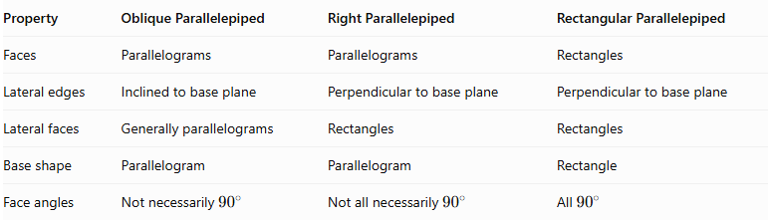
Property | Oblique Parallelepiped | Right Parallelepiped | Rectangular Parallelepiped
Faces | Parallelograms | Parallelograms | Rectangles
Lateral edges | Inclined to base plane | Perpendicular to base plane | Perpendicular to base plane
Lateral faces | Generally parallelograms | Rectangles | Rectangles
Base shape | Parallelogram | Parallelogram | Rectangle
Face angles | Not necessarily ${90}^{∘}$ | Not all necessarily ${90}^{∘}$ | All ${90}^{∘}$
Important distinction: An oblique parallelepiped is not the same as a right parallelepiped. The defining difference is whether the lateral edges are inclined or perpendicular to the base plane.

Constructing Oblique Parallelepiped in Solid Geometry

Geometric Instruments Used
# Source: AI Source: Provided by: [Data Path: Persons Table -> ID Column: 1, Name_En Column: Motasem Essam] -> From: [ChatGPT] on [7/25/2026]
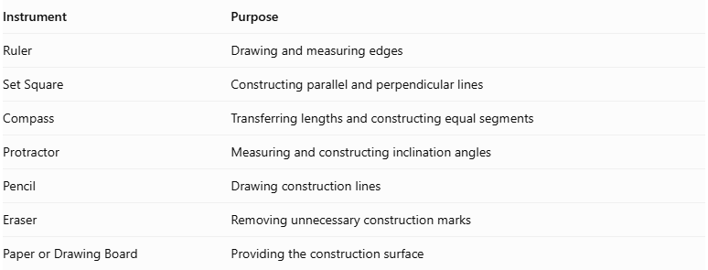
Instrument | Purpose
Ruler | Drawing and measuring edges
Set Square | Constructing parallel and perpendicular lines
Compass | Transferring lengths and constructing equal segments
Protractor | Measuring and constructing inclination angles
Pencil | Drawing construction lines
Eraser | Removing unnecessary construction marks
Paper or Drawing Board | Providing the construction surface

Instrument-Based Construction Procedures

Isometric Construction
# Source: AI Source: Provided by: [Data Path: Persons Table -> ID Column: 1, Name_En Column: Motasem Essam] -> From: [ChatGPT] on [7/25/2026]
- Draw a parallelogram representing the bottom base.
- Select an inclination direction for the lateral edges.
- Draw four equal, parallel lateral edges from the four base vertices.
- Ensure that the lateral edges are inclined rather than perpendicular to the base.
- Connect their upper endpoints to form the top parallelogram.
- Complete the six faces and twelve edges.
- Use dashed lines to represent hidden edges when necessary.

Oblique Projection Construction
# Source: AI Source: Provided by: [Data Path: Persons Table -> ID Column: 1, Name_En Column: Motasem Essam] -> From: [ChatGPT] on [7/25/2026]
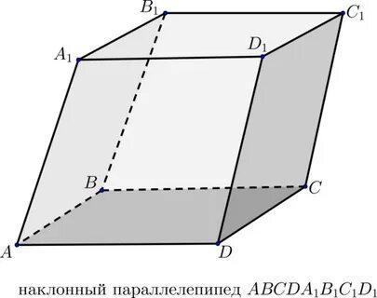
- Draw the front parallelogram representing the selected visible face.
- Choose an angle for the receding edges using a protractor.
- Draw four parallel receding edges of equal length.
- Connect their endpoints to construct the opposite face.
- Complete the remaining edges.
- Mark visible and hidden edges.

Face-Based Construction
# Source: AI Source: Provided by: [Data Path: Persons Table -> ID Column: 1, Name_En Column: Motasem Essam] -> From: [ChatGPT] on [7/25/2026]
- Construct the bottom parallelogram.
- Construct a congruent top parallelogram.
- Position both faces parallel to one another.
- Connect their corresponding vertices using equal, parallel, inclined edges.
- Verify that all six faces are parallelograms.

Edge-Based Construction
# Source: AI Source: Provided by: [Data Path: Persons Table -> ID Column: 1, Name_En Column: Motasem Essam] -> From: [ChatGPT] on [7/25/2026]
- Draw one parallelogram face.
- Construct four equal, parallel lateral edges from its vertices.
- Incline these edges relative to the selected base plane.
- Connect the endpoints to form the opposite parallelogram face.
- Complete the remaining edges and check parallelism.

Net-Based Construction
# Source: AI Source: Provided by: [Data Path: Persons Table -> ID Column: 1, Name_En Column: Motasem Essam] -> From: [ChatGPT] on [7/25/2026]
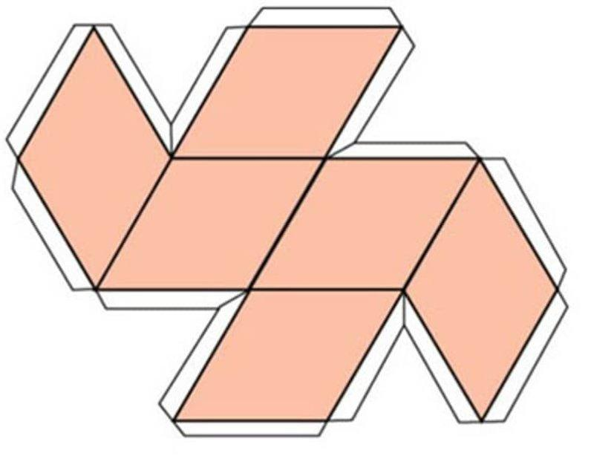
- Draw the six parallelogram faces in an unfolded arrangement.
- Ensure opposite faces are congruent.
- Connect the faces along corresponding equal-length edges.
- Add tabs if the net is intended for physical assembly.
- Cut, fold, and join the faces to form the oblique parallelepiped.

Real-World Applications
# Source: AI Source: Provided by: [Data Path: Persons Table -> ID Column: 1, Name_En Column: Motasem Essam] -> From: [ChatGPT] on [7/25/2026]
Oblique parallelepiped shapes can be found in:
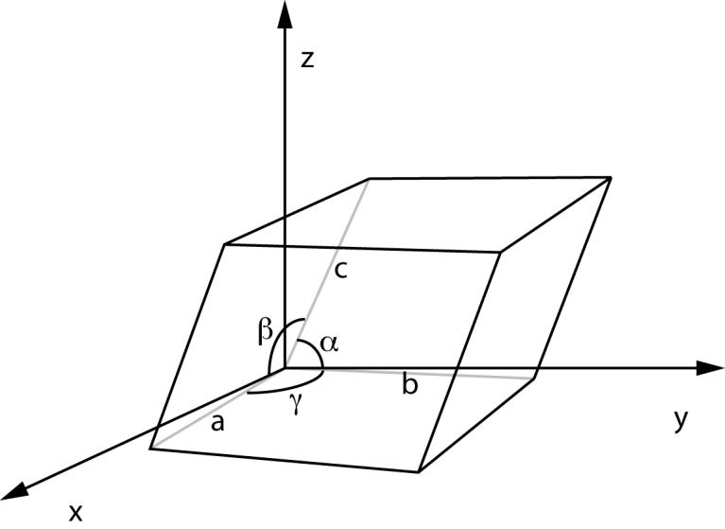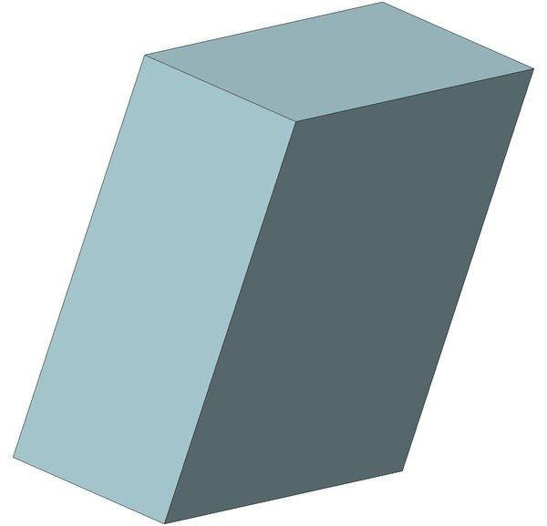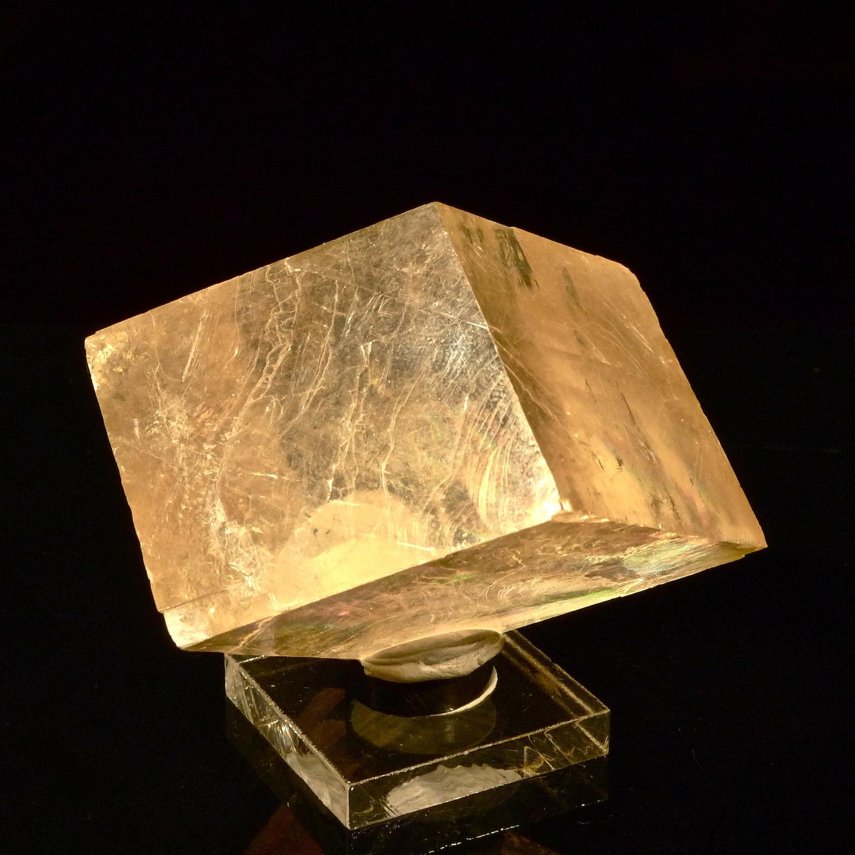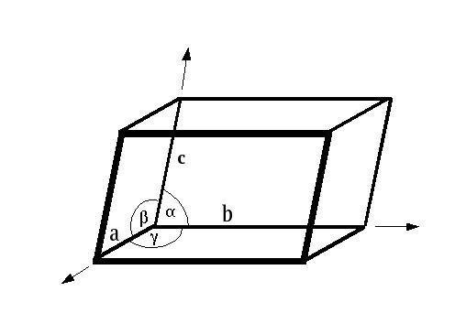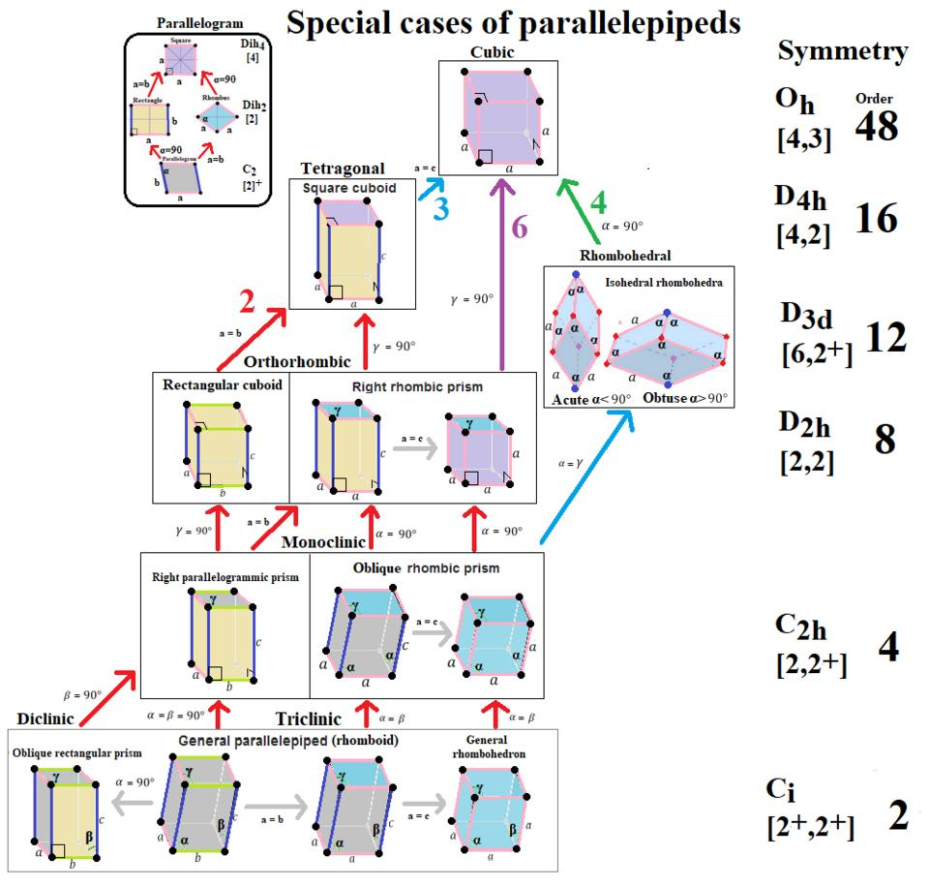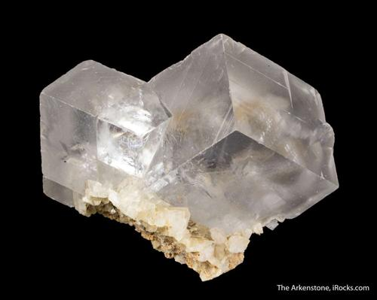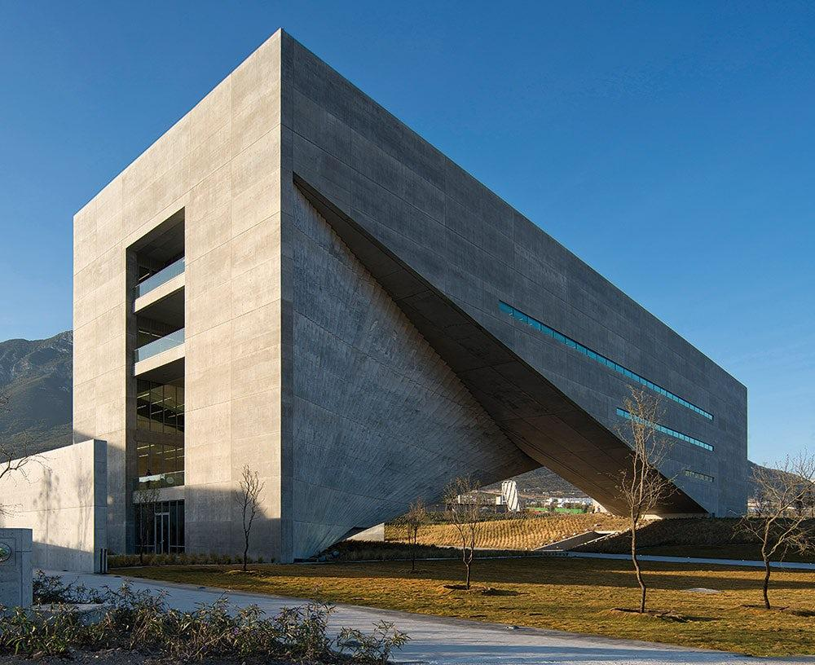
- Crystallography: Some crystal structures have parallelepiped-shaped unit cells with oblique angles.
- Architecture: Slanted structural blocks and geometric building forms.
- Engineering: Inclined mechanical components and structural models.
- Three-dimensional modeling: Modeling slanted solids and transformations.
- Geometry education: Studying volume, surface area, vectors, and spatial relationships.

Key Points
# Source: AI Source: Provided by: [Data Path: Persons Table -> ID Column: 1, Name_En Column: Motasem Essam] -> From: [ChatGPT] on [7/25/2026]
- An oblique parallelepiped is a solid with six parallelogram faces.
- Its lateral edges are inclined to its base plane.
- It has 6 faces, 12 edges, and 8 vertices.
- Opposite faces are parallel and congruent.
- Its perpendicular height is not equal to the inclined lateral-edge length.
- Its volume is $V=A_{bh}$.
- Its base area is $A_{b}=absinθ$.
- Its four space diagonals are not necessarily equal.
- Its bases can be rectangles, squares, rhombuses, or general parallelograms.

Conclusion
# Source: AI Source: Provided by: [Data Path: Persons Table -> ID Column: 1, Name_En Column: Motasem Essam] -> From: [ChatGPT] on [7/25/2026]
An oblique parallelepiped is a parallelepiped characterized by inclined lateral edges and six parallelogram faces. Its main geometric feature is the distinction between the inclined lateral-edge length and the perpendicular height. Understanding this distinction is essential when calculating its volume, surface area, and spatial dimensions.

